Create a git repository in local
- Open the GIT Bash and move to the local folder
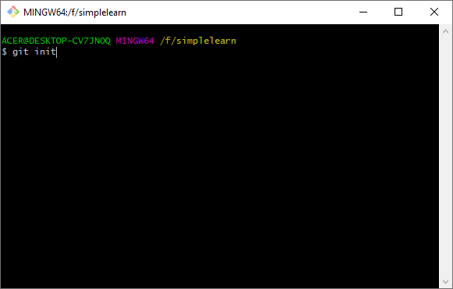
- Configure the github to the local folder
git remote add origin https://github.com/chockkalingamk/Simplilearn.git
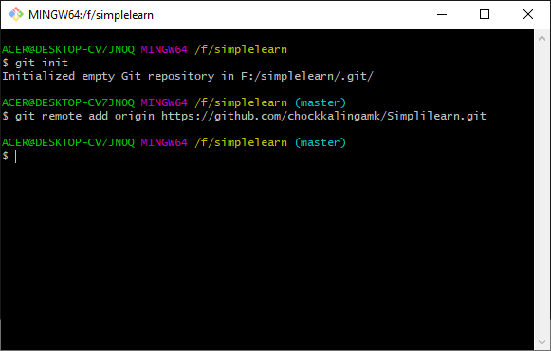

- Pull the source code folder from the GIT hub to local
git pull origin master
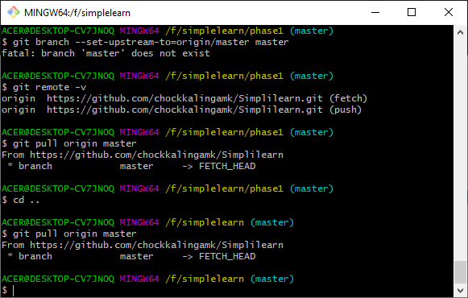
Import the source code of phase2/learner into the eclipse

- Import a new java project
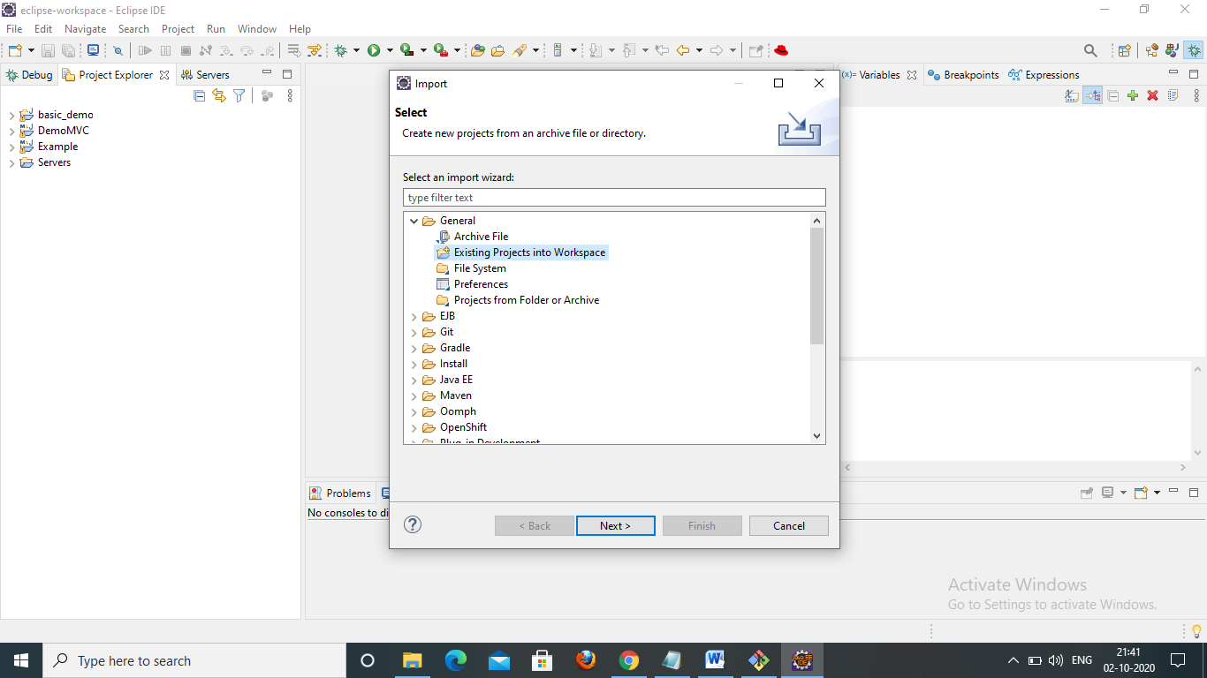
- Browse the directory from GIT
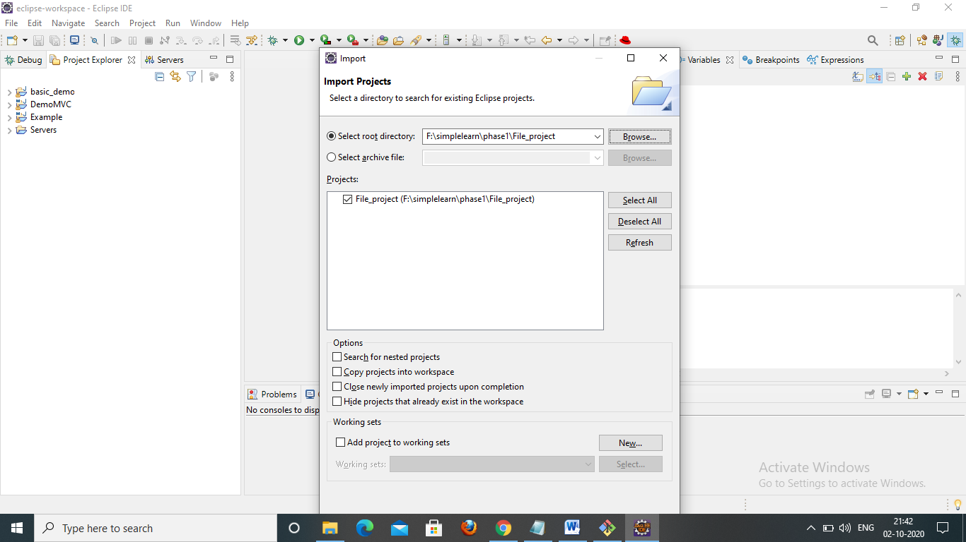
- Click Finish
- Install tomcat and provide the path in the prefrences
- Once the server is launched
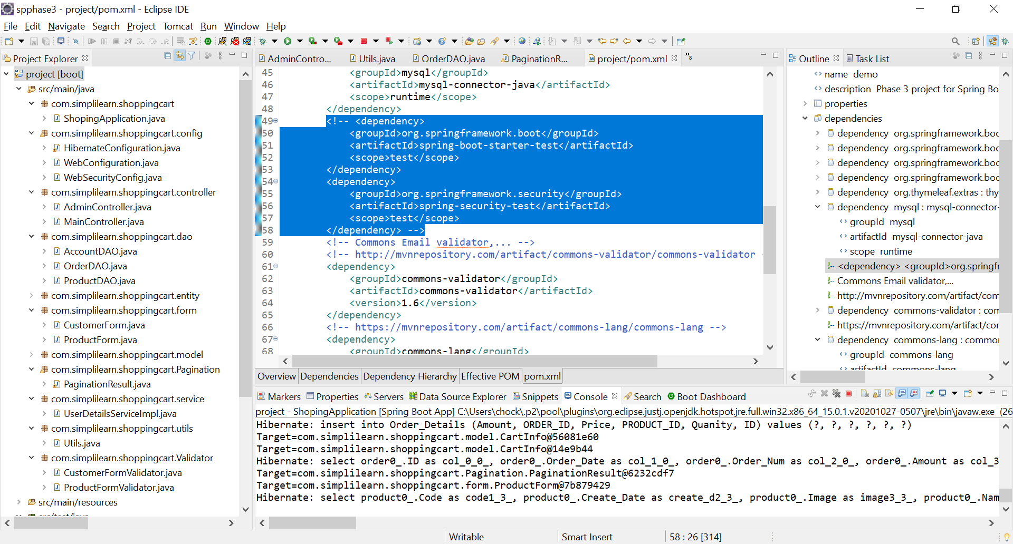
- Provide the URL http://localhost:8080/ to proceed with the application

